REPORT
E.C SSIP orientation 2022
On the day of 13th September, 2022, Orientation of 1st year E.C students was held in room no 3002 of Annexe building at 11.30 am. The aim of orientation was to make 1st year students about SSIP 2.O policy and encourage them on why to chose startup. HOD Dr. C. H. Vithlani, along department SSIP coordinator Dr. Nirali Kotak was present.
The orientation was started by a brief introduction about startup and entrepreneurship by hosts. The introduction contained the basics of startup and terms like pre-incubation.
Later Dr. Nirali Kotak further spoke about importance of startup and the environment that is being provided students. She also highlighted about benefits of moving to entrepreneurship at a young age.
After that HOD sir, gave his wise words to student about SSIP policy and about how they could utilize time making it worth. After that he walked through the steps to file a PoC and how the given Ideas will be evaluated, the financial allowance for innovation, mentor allowance and other supports.

.
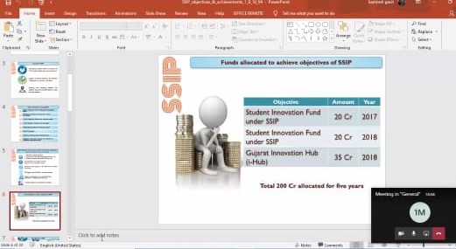
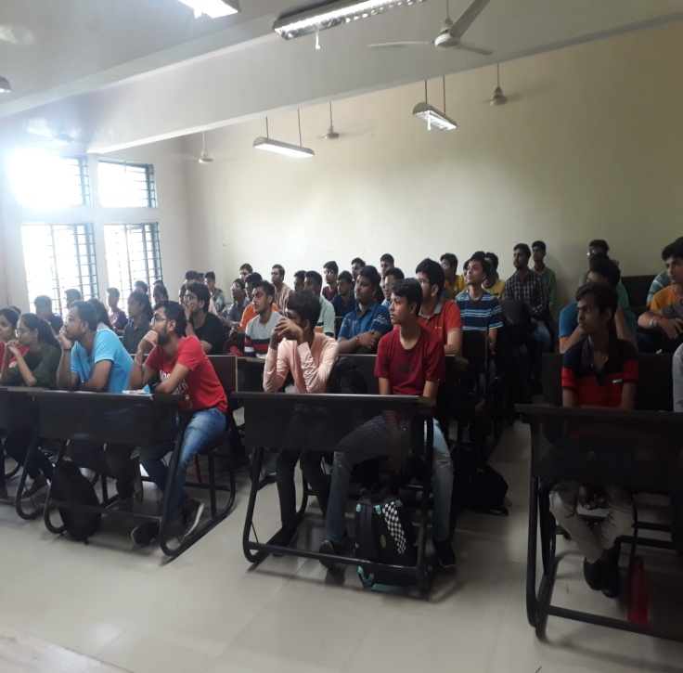 | 